Backup Solution for Individual Project

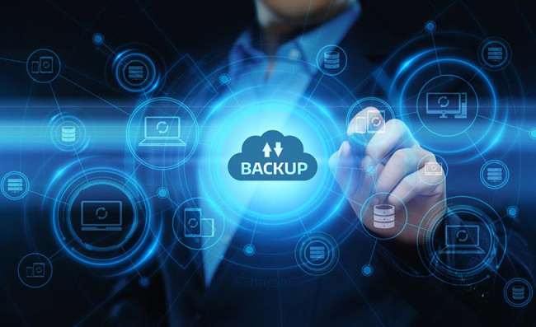

Table of Contents

Introduction 1

Regular Data Backups 1

Database and Persistent Data 1

Configuration and State 1

Disaster Recovery Plan 1

Multi-Cluster Deployment 1

Geographically Distributed Clusters 2

High Availability Configurations 2

Replica Sets and Redundancy 2

Load Balancing 2

Backup Kubernetes Cluster 3

Regular Snapshots 3

Automated Backup Scripts 3

Monitoring and Alerting 3

Continuous Monitoring 3

Alerting Mechanisms 4

Conclusion 4

# Introduction

In the dynamic landscape of modern web applications, ensuring the integrity and availability of data is paramount. Kubernetes, as a container orchestration platform, necessitates a robust backup and disaster recovery strategy. This article provides an in-depth exploration of a comprehensive backup solution for an individual project running on Kubernetes.

# Regular Data Backups

## Database and Persistent Data

For databases and persistent data, a reliable backup mechanism is crucial. PostgreSQL provides a versatile backup tool called pg_dump:

kubectl run postgres-backup --rm --tty -i --restart='Never' --namespace <namespace> --image=postgres:latest --env="PGPASSWORD=<db-password>" --command -- psql -h <db-host> -U <db-username> -d <db-name> -c 'COPY (SELECT * FROM <table-name>) TO STDOUT;' > backup.sql

(using dummy data here)

This command creates a backup of a specific table and saves it to a file named backup.sql. You can adapt this example to your specific database system.

## Configuration and State

For Kubernetes-specific resources, Velero is a powerful tool that simplifies the backup and restore process. It supports backup of cluster-wide objects, persistent volumes, and even custom resources. Here's a my use of Velero:

# Install Velero velero install --provider azure --plugins velero/velero-plugin-for-microsoft-azure:v1.2.1 # Create a backup velero backup create my-backup

Velero can be configured to run scheduled backups to ensure regular data protection.

# Disaster Recovery Plan

## Multi-Cluster Deployment

Maintaining a failover Kubernetes cluster is a crucial aspect of disaster recovery. Consider a scenario where you have a primary and backup cluster. Tools like kubectl or GitOps solutions can help synchronize configurations between the two clusters:

bashCopy code

# Synchronize Configurations kubectl get --export -o=json ns,deploy,svc | kubectl apply --context=<backup-cluster> -f -

By syncing the configurations periodically, you ensure that your backup cluster is ready to take over in case of a failure in the primary cluster.

## Geographically Distributed Clusters

Cloud providers offer geographical distribution options for Kubernetes clusters. Azure, for example, allows you to deploy clusters across multiple regions. By leveraging this capability, you can reduce the risk associated with a single point of failure. Here's an example of creating a geographically distributed AKS cluster:

az aks create --resource-group <resource-group> --name <cluster-name1> --location eastus --node-count 3 az aks create --resource-group <resource-group> --name <cluster-name2> --location westus --node-count 3

# High Availability Configurations

## Replica Sets and Redundancy

Designing your Kubernetes deployment with redundancy is vital for high availability. Consider using ReplicaSets or Deployments for critical components of your application. Here's my Deployment redundancy configuration:

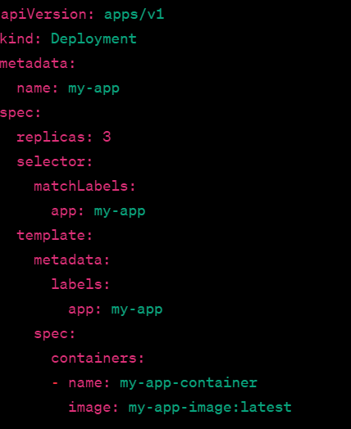

This Deployment ensures that there are always three replicas of your application running, providing redundancy.

## Load Balancing

Implementing a robust load balancer is essential for distributing traffic across multiple instances, ensuring availability even if one instance fails. Cloud providers typically offer load balancing services. For example, in Azure, you can create a LoadBalancer service:

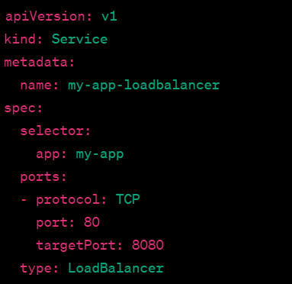

# Backup Kubernetes Cluster

## Regular Snapshots

Taking snapshots of the entire Kubernetes cluster at regular intervals is essential for disaster recovery. Cloud providers offer features to create snapshots. Here's an example using Azure CLI:

# Create Snapshot az snapshot create --resource-group <resource-group> --name <snapshot-name> --sku Standard_LRS --size-gb 30 --source <disk-id>

This command creates a snapshot of a specific disk in your cluster.

## Automated Backup Scripts

Automation is key to a reliable backup strategy. Developing scripts or using tools like Velero to automate the backup process simplifies the task. Here's an example script for automating Velero backups:

# Velero Backup Script velero backup create my-automatic-backup

Automating this script using cron or another scheduler ensures regular backups.

# Monitoring and Alerting

## Continuous Monitoring

Setting up continuous monitoring tools is vital for detecting issues early. Tools like Prometheus and Grafana can provide insights into the health and performance of your Kubernetes cluster. Here's an example using Prometheus:

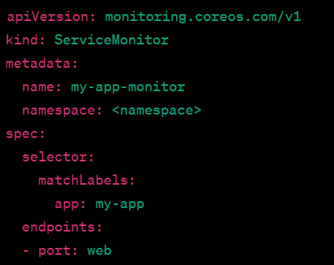

This ServiceMonitor configuration collects metrics for your application.

## Alerting Mechanisms

Configuring alerting systems is crucial for immediate notification of cluster failures or performance degradation. Tools like Azure Monitor can be used here to send you a notification if there is a problem.

# Conclusion

A comprehensive Kubernetes backup and disaster recovery strategy involves regular data backups, a well-thought-out disaster recovery plan, configurations for high availability, regular backups of the entire Kubernetes cluster, and a robust monitoring and alerting system. Implementing these practices ensures the resilience of your individual project, safeguarding against data loss and minimizing downtime. As Kubernetes continues to evolve, staying abreast of best practices and leveraging the latest tools will contribute to a more resilient and reliable deployment.